2022 has been a banner year connecting with more people than Christian Science in Metro Chicago has ever reached before! We’ve “enlarged the place of our tent” (see Isaiah 54:2) and extended a welcoming hand to those seeking spiritual solutions and a spiritual approach to living. **We hope you’ll join us on Saturday, November 5 @ 10am CT via zoom** to learn more about the good works of this joint activity and to learn how you and the area Christian Science churches can benefit from our communication and promotion activity. (zoom link on csmetrochicago.org)

The focus of Christian Science in Metro Chicago’s activities falls into four categories:  
1. Foundational outreach/seeking seekers/ getting the word out (Online advertising, website and social media, expos)  
2. Attracting seekers to Christian Science Manual-based activities (Church, Sunday School, Reading Rooms, Lectures, Bible Lesson/Sentinel Watch, other CSPS content, promoting *Science and Health*)  
3. Connecting churches and students of Christian Science with each other and supporting church activities (newsletters, announcements, best practices)  
4. Healing (phone helpline and website)

Highlights of 2022 include new online advertising with messages that invite viewers to join us at Wednesday testimony meetings and Christian Science lectures, and to make use of the 20+ Reading Rooms in the Chicago area. These ads have been seen nearly 1,000,000 times and helped to increase the website’s usefulness – visits are up 20% so far this year. The telephone helpline too has been accessed more than in recent years, an increase of 5% unique callers over 2021.

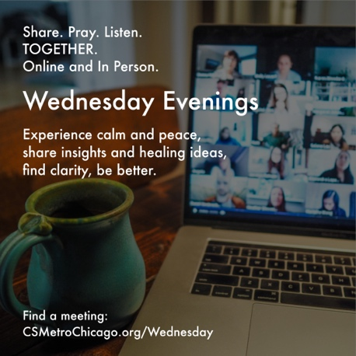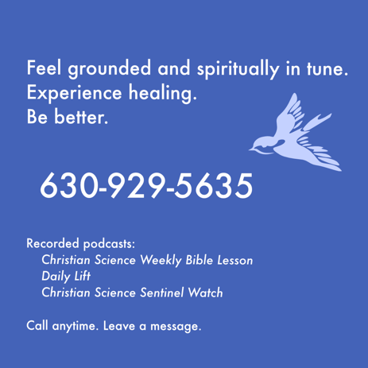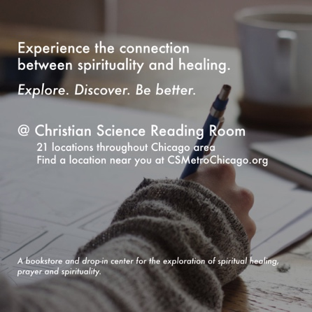

Anticipated activities and expenses during 2023 include the following:

|  |  |  |
| --- | --- | --- |
| **2023 Anticipated Activities** | **Estimated Costs** | **Expected Outcomes** |
| **WEBSITE**: Maintaining a robust website designed to promote all lectures, Reading Rooms, and church services in Metro Chicago. | $22,000 | 28,000 page views/yr; 25% return visitors; 1m 40s visit length |
| **ADVERTISING**: Expanding our advertising presence on Google and Meta platforms to promote Chicago area Wednesday meetings, Reading Rooms, and lectures. | $20,000 | 1,140,000 ad impressions;  440 Facebook & 350 Instagram followers |
| **HELPLINE**: Maintaining a telephone helpline that broadcasts the Bible Lesson, Daily Lift, and Sentinel Watch available from The Christian Science Publishing Society. | $19,500 | 30 reported healings/yr  430 listeners/mo |
| **EXPOS**: Exhibiting at one or two Body, Mind, Spirit Expos to promote SH, Reading Rooms, CS literature and lectures. Coordinate lecturing opportunity for churches at expos. | $5,000 | 275 conversations; 2 lectures with 20-30 new attendees; 12 SH sold |
| **FIELD COMMUNICATION**: Providing a communication channel that shares news about events and Chicago area CS resources as well as providing area churches with info/tips and promotional materials. | $19,000 | 525 email subscribers;  26 enewsletters/yr with 50% opens, 20% clicks; “Intro to RR” video series; church info webinars |
| **Total 2023 Anticipated Expenses** | **$85,500** |  |

**This plan is being formally presented and ratified at CSMetroChicago’s Annual Business Meeting on November 5th. Each church is requested to have a delegate present at the meeting to ratify the plan OR respond by email, info@csmetrochicago.org, before November 1 st.**Your financial support, as individuals and collectively through branch church and society donations, will enable these activities to move forward. Financial contributions can be sent to Christian Science in Metro Chicago, P.O. Box 768, Chicago, IL 60690-0768.